SMART STP PREDICION SYSTEM USING CNN-LSTM-ATTENTION MODEL
A Project report submitted in partial fulfillment of the requirements for the award of the
Degree of
BACHELOR OF TECHNOLOGY
IN
COMPUTER SCIENCE AND SYSTEM ENGINEERING

Submitted by

DODDI MAHENDRA | 322506402094
EDIBILLI TANU SREE | 322506402102
GATTEM INDRA RAMA ROA | 322506402115
GORLE SHYAM PRASAD NAIDU | 322506402125
GULIVINDALA BHANU PRASAD | 323506402134
Under the esteemed guidance of

Dr.N.P.LAVANYA KUMARI

Assistant professor
Department of computer Science and Systems Engineering

DEPARTMENT OF COMPUTER SCIENCE AND SYSTEMS ENGINEERING ANDHRA UNIVERSITY COLLEGE OF ENGINEERING (A)
ANDHRA UNIVERSITY VISAKHAPATNAM – 530003
2022 – 2026

BLOOD GROUP DETECTION USING FINGERPRINT IMAGES

This is to certify that the main project entitled “Smart STP Prediction System Using CNN- LSTM-Attention Model” is the Bonafide work done DODDI MAHENDRA (322506402094), EDIBILLI TANU SREE (322506402102), GATTEM INDRA RAMA RAO (322506402115), GORLE SHYAM PRASAD (32250640125), GULIVINDALA BHANU PRASAD Submitted in
the partial fulfilment of the requirement for the award of the Degree of Bachelor of Technology in computer Science and Systems Engineering during December 2025 - April 2026

Project Guide Head of the Department
Dr.N.P.LAVANYA Kumari Prof. Valli Kumari Vatsavayi
Assistant Professor
Department of CS&SE Department of CS&SE

DECLARATION

We hereby declare that the project work entitled “SMART STP PREDICTION SYSTEM USING CNN-LSTM-ATTENTION MODEL” is a bonafide work done by us, under the esteemed guidance of Dr.N.P.Lavanya Kumari, Assistant Professor, Department of CS&SE, College of Engineering.

This project report is being submitted in partial fulfillment of the requirements for the award of Degree of Bachelor of Technology in Computer Science and System Engineering during the academic year 2024-2025.This project possesses originally as it not extracted from any source and it had not been submitted to any other institution or university.

NAME | REGD.NO | SIGNATURE
DODDI MAHENDRA | 322506402094
EDIBILLI TANU SREE | 322506402102
GATTEM INDRA RAMA RAO | 322506402115
GORLE SHYAM NADIU | 322506402125
GULIVINDALA BHANU PRASAD | 323506402134

Visakhapatnam

ACKNOWLEDGEMENT

We take this opportunity to express deep gratitude to the people who have been instrumental in the successful completion of the project.
We would like to think our project guide, Assistant Professor Dr.N.P.Lavanya Kumari, Department of Computer Science and System Engineering, for the supervision and support, which was greatly helpful in the progression and smoothness of the entire project work.
We would like to thank Prof.Valli Kumari Vatsavayi, Head of the Department, Computer Science and Engineering.
We would like to show our gratitude to our beloved Principal, Prof. M.Sashi College of Engineering, for his encourage in the aspect of our course, who gave us
official support for the progress of our project.

We would also like to extend our gratitude to Lab Technicians and our sincere gratitude to all the faculty members and Non-Teaching Staff in the Department of computer Science and System engineering for supporting us. We would also like to thank our parents and friends, who have willingly helped us out with their abilities in completing the project work.

With Gratitude,

Doddi DODDI MAHENDRA | 322506402080
Edibilli Tanu sree | 322506402093
Gattem EDIBILLI TANU SREE Rama Rao | 322506402121
Gorle GATTEM INDRA RAMA ROA Prasad | 322506402125
Gulivindala GORLE SHYAM PRASAD NAIDU prasad | 323506402134

ABSTRACT
Wastewater treatment plants (STPs) operate in highly variable conditions where influent composition, hydraulic load, weather patterns, and process disturbances influence effluent quality indicators such as Biochemical Oxygen Demand (BOD), Chemical Oxygen Demand (COD), Dissolved Oxygen (DO), and pH. Accurate short-term forecasting of these parameters is essential for proactive control, compliance management, and process optimization. This project presents a deep-learning-based Smart STP Prediction System that uses a hybrid CNN- LSTM-Attention architecture to model nonlinear temporal dynamics in daily wastewater data. The convolutional branch captures local temporal patterns, the LSTM layers model long-range dependencies, and the attention mechanism emphasizes the most informative sequence regions during prediction. A complete pipeline is implemented, including data preprocessing, min-max normalization, sliding-window sequence generation, model training, evaluation through RMSE, MAE, R2, and MAPE, and visualization-based error analysis. Experimental results on multi-parameter synthetic daily STP data demonstrate strong performance for BOD and COD and stable predictive behavior for DO and pH under noisy conditions. The project extends beyond modeling by integrating a FastAPI inference backend and a Flutter client for file upload and prediction display, thereby forming a practical end-to-end system. The proposed approach demonstrates the feasibility of intelligent wastewater forecasting for smart utility operations and lays a foundation for real-world digital monitoring frameworks.

TABLE OF CONTENTS

ABSTRACT v
LIST OF FIGURES viii
LIST OF TABLES ix
CHAPTER 1: INTRODUCTION
  - Background of Wastewater Treatment Plants 1
  - Need for Prediction Systems in STP Operations 2
  - Challenges in Fluctuating Parameters 3
  - Role of AI and Deep Learning 4
  - Problem Statement 5
  - Objectives 5
  - Scope of the Project 6
CHAPTER 2: LITERATURE REVIEW
  - Linear Regression 7
  - K-Nearest Neighbors (KNN) 8
  - Random Forest 11
  - Artificial Neural Networks (ANN) 12
  - ARIMA 14
CHAPTER 3: METHODOLOGY
  - Data Collection 17
  - Data Preprocessing 17
    - Missing Value Handling 17
    - Outlier Removal Using IQR 18
    - Normalization 18
  - Time-Series Windowing 19
  - Model Architecture 21
    - CNN Module 21
    - LSTM Module 22
    - Attention Mechanism 23
    - Integrated CNN-LSTM-Attention Network 24
  - Training Setup 25
CHAPTER 4: RESULTS AND ANALYSIS
  - Evaluation Metrics 28
  - Dissolved Oxygen (DO) Analysis 28
  - pH Analysis 30
  - BOD Analysis 32
  - COD Analysis 35
  - Training Dynamics 37
CHAPTER 5: CONCLUSION
Conclusion 39
Future Work 40
REFERENCES 41

LIST OF FIGURES

FIGURE | NAME OF THE FIGURE | PAGE
1 | Wastewater Treatment Plant Process Flow | 2
2 | Typical Wastewater Flow Diagram | 3
3 | Environmental Impact of Untreated Wastewater | 4
4 | Linear Regression Graph | 8
5 | KNN Classification Example | 11
6 | Random Forest Structure | 12
7 | Artificial Neural Network Diagram | 13
8 | ARIIMA Time Series Graph | 15
9 | Data Preprocessing Pipeline | 19
10 | Data Normalization Graph | 19
11 | Time Series Windowing | 20
12 | CNN Architecture Diagram | 22
13 | LSTM Cell Structure | 23
14 | Attention Mechanism Visualization | 24
15 | Complete CNN-LSTM-Attention Model | 25
16 | Predictions, Residuals and Scatter Plot for DO, pH, BOD, COD | 29 TO 37
17 | Training Loss Curve | 37
18 | Model Accuracy Curve | 38

LIST OF TABLES

TABLE | NAME OF THE TABLE | PAGE NO
1 | Comparison of Existing Models | 15
2 | Model Hyperparameters | 26
3 | Performance Metrics | 38

CHAPTER 1: INTRODUCTION

Background of Wastewater Treatment Plants
Wastewater treatment plant operation is central to this project because wastewater quality monitoring depends on consistent interpretation of dynamic and multi-dimensional process variables over time. In practical treatment plants, operators face seasonal inflow changes, load shocks, and process disturbances; therefore, influent and effluent quality forecasting must be analyzed with both engineering context and statistical rigor. The present work addresses these realities by combining domain knowledge from sanitation engineering with data-driven learning, ensuring that model behavior remains meaningful for operational decision support. The report evaluates not only numerical accuracy but also interpretability through trend plots, residual diagnostics, and comparative assessment across multiple physicochemical indicators. From a methodological perspective, time-series structure is preserved through windowed supervision so that historical trajectories influence forward prediction in a realistic way. This design helps the model capture temporal inertia, gradual drift, and abrupt variability while reducing the risk of overfitting to isolated fluctuations in the training subset. Within SMART STP PREDICION SYSTEM USING CNN-LSTM-ATTENTION MODEL, experiments are organized to measure how effectively hybrid deep learning can represent nonlinearity, delayed effects, and inter-parameter coupling observed in treatment datasets. Results are interpreted in relation to process plausibility, where lower prediction error translates into better readiness for early warning, aeration planning, and compliance-driven monitoring. The discussion therefore links WHY the method is needed, HOW the computational pipeline is implemented, and WHAT outcomes are obtained under realistic evaluation metrics. Such an integrated presentation is academically important because it transforms a model-centric study into an engineering-oriented system that supports future deployment in smart urban infrastructure.

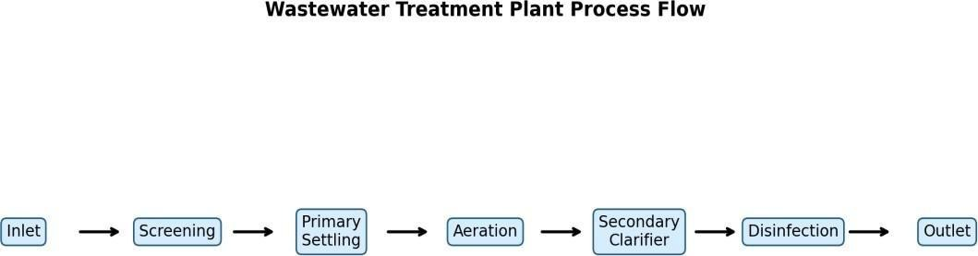

Fig 1.1: Wastewater Treatment Plant Process Flow

Need for Prediction Systems in STP Operations

Prediction systems in wastewater treatment plants are essential for transforming conventional reactive operations into proactive and intelligent process management frameworks. In traditional systems, operators rely heavily on periodic sampling and laboratory analysis, which introduces delays in decision-making and limits the ability to respond effectively to sudden fluctuations in influent characteristics or process disturbances. As wastewater treatment involves highly dynamic and interdependent parameters such as Biochemical Oxygen Demand (BOD), Chemical Oxygen Demand (COD), Dissolved Oxygen (DO), and pH, the absence of predictive capabilities can lead to inefficiencies, regulatory violations, and environmental risks. Therefore, there is a growing need for advanced prediction systems that can continuously analyze historical and real-time data to forecast future conditions with high accuracy. By incorporating data-driven models, treatment facilities can anticipate variations in load conditions, detect anomalies at an early stage, and optimize operational parameters such as aeration rates, chemical dosing, and sludge management strategies. These systems not only enhance treatment efficiency but also reduce operational costs and energy consumption. Furthermore, predictive systems contribute to sustainable wastewater management by ensuring consistent compliance with environmental discharge standards and minimizing the ecological impact of untreated or partially treated effluent. In the context of smart cities and digital infrastructure, integrating predictive analytics into wastewater treatment plants represents a significant

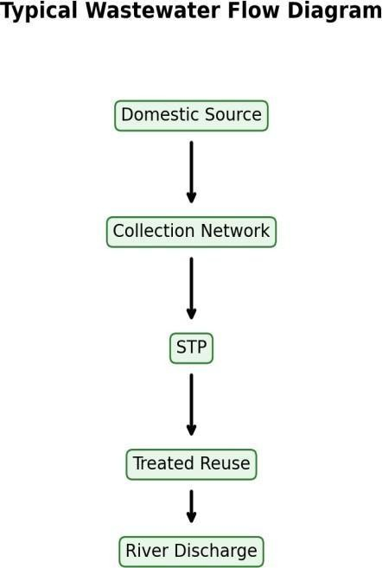

Fig 1.2: Typical Wastewater Flow Diagram

Challenges in Fluctuating Parameters

Wastewater treatment processes are inherently complex due to the highly variable nature of influent composition and operational conditions, making accurate modeling and prediction a challenging task. The variability arises from multiple sources, including seasonal changes, industrial discharges, population dynamics, rainfall events, and unexpected shock loads, all of which contribute to significant fluctuations in key water quality parameters. These parameters do not behave independently; instead, they exhibit nonlinear relationships and interdependencies that evolve over time. For instance, variations in organic load directly influence dissolved oxygen levels, which in turn affect microbial activity and overall treatment efficiency. Additionally, the presence of noise, missing values, and measurement inconsistencies further complicates data analysis and model development. Another major challenge lies in capturing temporal dependencies, as wastewater processes often exhibit delayed responses where the effect of a change in one parameter may not be immediately visible in another

This time-lag behavior requires models that can effectively learn from historical sequences
rather than relying solely on current observations. Moreover, abrupt disturbances such as
equipment failure or sudden inflow surges introduce irregular patterns that are difficult to
generalize using traditional modeling approaches. Addressing these challenges requires robust
computational techniques capable of handling multivariate time-series data, capturing both
short-term variations and long-term trends, and maintaining stability under uncertain and
noisy conditions. Overcoming these limitations is critical for developing reliable prediction
systems that can support real-time decision-making in wastewater treatment operations.
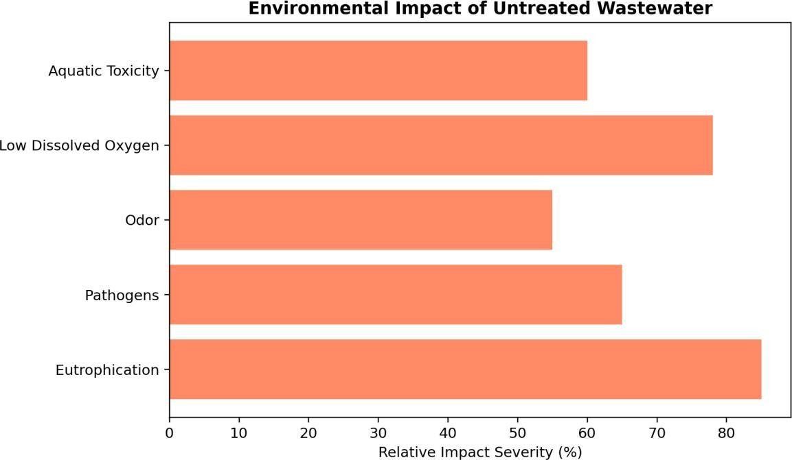

Fig 1.3: Environmental Impact of Untreated Wastewater

Role of AI and Deep Learning

Artificial Intelligence and Deep Learning have emerged as powerful tools for
addressing the complexities associated with wastewater treatment data analysis and prediction.
Unlike conventional statistical models that rely on predefined assumptions and linear
relationships, deep learning approaches are capable of automatically learning intricate patterns
and representations directly from raw data. This capability is particularly important in

wastewater systems, where the relationships between variables are highly nonlinear, time
dependent, and influenced by multiple interacting factors. Techniques such as Convolutional
Neural Networks (CNN) are effective in extracting local temporal features and identifying
short-term patterns within the data, while Long Short-Term Memory (LSTM) networks are
specifically designed to capture long-range dependencies and sequential behavior in time
series data. The integration of attention mechanisms further enhances model performance by
enabling the system to focus on the most relevant portions of the input sequence, thereby
improving interpretability and prediction accuracy. By combining these techniques into a
hybrid architecture, it becomes possible to model complex wastewater dynamics with greater
precision and reliability. In addition to improved predictive performance, AI-driven systems
offer scalability and adaptability, allowing them to be applied across different treatment plants
and varying operational conditions. The use of deep learning also facilitates continuous
learning, where models can be updated with new data to maintain accuracy over time. As a
result, AI and deep learning play a critical role in advancing wastewater treatment from a
manually operated system to an intelligent, automated, and data-driven process that supports
efficient resource management and environmental sustainability.

Problem Statement
Conventional monitoring approaches in wastewater treatment plants are reactive and often rely on delayed laboratory results, making it difficult to anticipate process instability in time. Manual interpretation of multivariate daily records is limited when variables exhibit nonlinearity, temporal lag, and noise. As a result, treatment operators may miss early warnings related to high organic load or oxygen imbalance, affecting discharge quality and compliance. The core problem addressed in this project is the development of an accurate and reliable short- term forecasting system capable of learning temporal dependencies across multiple STP parameters and producing actionable predictions for operational planning.

Objectives
    - To design a complete data-to-deployment pipeline for STP parameter forecasting.
    - To preprocess daily wastewater data using robust cleaning and normalization procedures.

    - To build a hybrid CNN-LSTM-Attention architecture for time-series prediction.
    - To evaluate model quality using RMSE, MAE, R2, and MAPE metrics.
    - To perform residual and scatter diagnostics for interpretability.
    - To forecast future parameter values for operational decision support.
    - To deploy a FastAPI backend for practical inference.
    - To integrate a Flutter interface for user-facing prediction workflows.

Scope of the Project

The scope of this project encompasses the design, development, and deployment of an
intelligent prediction system for wastewater treatment plants using advanced deep learning
techniques. The project begins with the collection and preprocessing of multivariate time
series data, ensuring that the dataset is cleaned, normalized, and structured in a manner
suitable for model training. It includes handling missing values, removing outliers, and
transforming raw data into supervised learning format through time-series windowing
techniques. The core component of the project involves the development of a hybrid CNN
LSTM-Attention model that integrates the strengths of convolutional feature extraction,
sequential memory learning, and attention-based weighting to accurately predict key
wastewater parameters such as BOD, COD, DO, and pH. The model is trained and evaluated
using multiple performance metrics, including RMSE, MAE, R², and MAPE, to ensure a
comprehensive assessment of prediction accuracy and reliability. In addition to model
development, the project also focuses on interpretability through visualization techniques such
as trend plots, residual analysis, and scatter plots, which provide insights into model behavior
and performance. Furthermore, the system is extended beyond theoretical implementation by
incorporating a FastAPI-based backend for model inference and a Flutter-based frontend for
user interaction, enabling real-time prediction and data visualization. The project aims to
bridge the gap between research and practical application by delivering a complete end-to-end
solution that can be deployed in real-world wastewater treatment scenarios. Ultimately, this
work contributes to the development of smart wastewater management systems that enhance
operational efficiency, reduce environmental impact, and support sustainable urban
infrastructure

CHAPTER 2: LITERATURE REVIEW

Linear Regression

Linear Regression is among the earliest supervised learning techniques used for
predictive modeling. The model assumes a linear relation between an independent variable set
and a dependent target variable, commonly represented as y = beta0 + beta1 x1 + beta2 x2 +
... + epsilon. In wastewater quality forecasting, linear regression can provide baseline estimates
when relationships are approximately monotonic and low-dimensional. Its strengths include
interpretability, computational simplicity, and transparent coefficient analysis; however, real
treatment-plant data often violate linear assumptions due to saturation effects, threshold
behavior, and cross-variable interactions. Consequently, while linear regression is useful for
benchmarking and exploratory diagnostics, it generally underperforms in high-variance,
nonlinear time- series settings where lagged dependencies dominate.

Linear Regression is one of the most fundamental and widely used supervised learning
algorithms for predictive modeling, particularly when the relationship between independent
variables and the target variable can be approximated using a linear function. The model
operates by fitting a best-fit line through the data points by minimizing the error between
predicted and actual values, typically using the least squares method. Mathematically, it
represents the dependent variable as a weighted sum of input features along with a bias term,
enabling straightforward interpretation of how each feature influences the output. In
wastewater treatment applications, Linear Regression can be used to estimate parameters such
as Biochemical Oxygen Demand (BOD) or Chemical Oxygen Demand (COD) based on
measurable environmental and operational factors. Its primary advantages include simplicity,
transparency, low computational cost, and ease of implementation, making it highly suitable
for baseline analysis and initial experimentation. However, wastewater systems are inherently
nonlinear and dynamic, where parameters interact in complex ways influenced by biological,
chemical, and physical processes. Linear Regression fails to capture these nonlinear
interactions, temporal dependencies, and delayed effects that are commonly observed in
treatment plants. Additionally, it is sensitive to multicollinearity among features and may
produce unreliable predictions when input variables are highly correlated. Despite these
limitations, Linear Regression remains an essential benchmarking tool, providing a reference
point against which more advanced machine learning and deep learning models can be
evaluated in terms of performance and accuracy

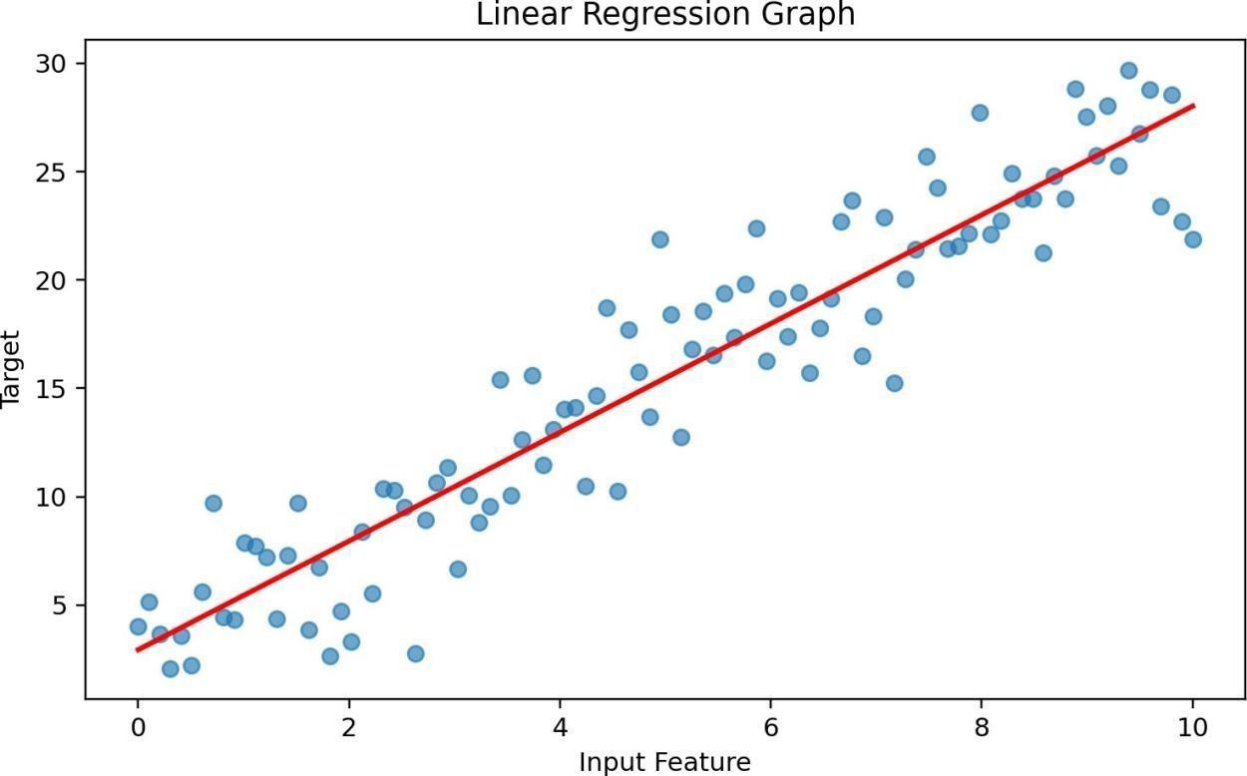

Fig 2.1: Linear Regression Graph

K-Nearest Neighbors (KNN)

K-Nearest Neighbors (KNN) is a non-parametric, instance-based learning algorithm
that makes predictions based on the similarity between data points rather than learning an
explicit mathematical model. It operates by identifying the ‘k’ closest data points to a
given query instance using a distance metric such as Euclidean, Manhattan, or Minkowski
distance, and then determining the output based on the majority or average of these neighbors
. In wastewater treatment systems, KNN can be used to estimate parameter values by
comparing current observations with historical records that exhibit similar patterns. This
makes it particularly useful for capturing local structures and relationships within the dataset.
One of the key advantages of KNN is its simplicity and flexibility, as it does not assume any
specific distribution of the data and can adapt to complex patterns.

However, the algorithm has several drawbacks when applied to large-scale and time
dependent datasets. It requires storing the entire dataset in memory, making it computationally
expensive during prediction, especially as the dataset grows. Furthermore, KNN is highly
sensitive to feature scaling, meaning that improper normalization can significantly distort
distance calculations and degrade performance. Another major limitation is its inability to
inherently capture temporal dependencies, which are crucial in wastewater systems where past
conditions strongly influence future behavior. Additionally, the choice of the parameter ‘k
’ plays a critical role in determining model performance, and selecting an inappropriate
value can lead to either overfitting or underfitting. While KNN can provide reasonable
predictions in simple scenarios, its limitations make it less suitable for complex, multivariate,
and time-series wastewater forecasting tasks.
KNN distance-based learning is central to this project because wastewater quality
monitoring depends on consistent interpretation of dynamic and multi-dimensional process
variables over time. In practical treatment plants, operators face seasonal inflow changes, load
shocks, and process disturbances; therefore, local neighborhood inference in multidimensional
space must be analyzed with both engineering context and statistical rigor. The present work
addresses these realities by combining domain knowledge from sanitation engineering with
data-driven learning, ensuring that model behavior remains meaningful for operational
decision support. The report evaluates not only numerical accuracy but also interpretability
through trend plots, residual diagnostics, and comparative assessment across multiple
physicochemical indicators. From a methodological perspective, time-series structure is
preserved through windowed supervision so that historical trajectories influence forward
prediction in a realistic way. This design helps the model capture temporal inertia, gradual drift,
and abrupt variability while reducing the risk of overfitting to isolated fluctuations in the
training subset. Within Smart STP Prediction System Using CNN-LSTM-Attention Model,
experiments are organized to measure how effectively hybrid deep learning can represent
nonlinearity, delayed effects, and inter-parameter coupling observed in treatment datasets.
Results are interpreted in relation to process plausibility, where lower prediction error translates
into better readiness for early warning, aeration planning, and compliance-driven monitoring.
The discussion therefore links WHY the method is needed, HOW the computational pipeline
is implemented, and WHAT outcomes are obtained under realistic evaluation metrics. Such an
integrated presentation is academically important because it transforms a model-centric study academically important because it transforms a model-centric study

When you want to classify a data point into a category like spam or not spam, the
KNN algorithm looks at the K closest points in the dataset. These closest points are called
neighbors. The algorithm then looks at which category the neighbors belong to and picks the
one that appears the most. This is called majority voting.In regression, the algorithm still looks
for the K closest points. But instead of voting for a class in classification, it takes the average
of the values of those K neighbors. This average is the predicted value for the new point for
the algorithm.
The present work addresses these realities by combining domain knowledge from
sanitation engineering with data-driven learning, ensuring that model behavior remains
meaningful for operational decision support. The report evaluates not only numerical accuracy
but also interpretability through trend plots, residual diagnostics, and comparative assessment
across multiple physicochemical indicators. From a methodological perspective, time-series
structure is preserved through windowed supervision so that historical trajectories influence
forward prediction in a realistic way. This design helps the model capture temporal inertia,
gradual drift, and abrupt variability while reducing the risk of overfitting to isolated
fluctuations in the training subset. Within Smart STP Prediction System Using CNN-LSTM
Attention Model, experiments are organized to measure how effectively hybrid deep learning
can represent nonlinearity, delayed effects, and inter-parameter coupling observed in treatment
datasets. Results are interpreted in relation to process plausibility, where lower prediction error
translates into better readiness for early warning, aeration planning, and compliance-driven
monitoring.
The discussion therefore links WHY the method is needed, HOW the computational
pipeline is implemented, and WHAT outcomes are obtained under realistic evaluation metrics.
Such an integrated presentation is academically important because it transforms a model
centric study into an engineering-oriented system that supports future deployment in smart
urban infrastructure.
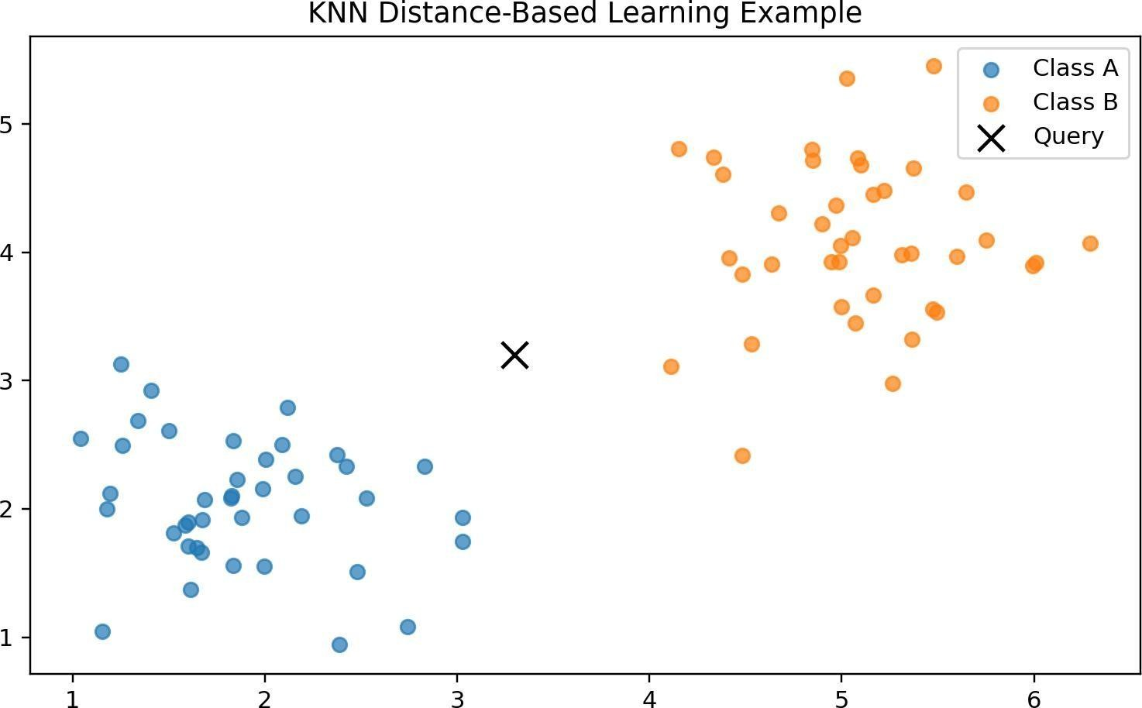

Fig 2.2: KNN Classification Example

Random Forest

Random Forest is an ensemble machine learning algorithm that improves prediction
accuracy by combining multiple decision trees through a process known as bagging (bootstrap
aggregation). Each decision tree is trained on a randomly selected subset of the dataset and
features, which introduces diversity among the trees and reduces the risk of overfitting. The
final prediction is obtained by averaging the outputs of all individual trees in regression tasks,
resulting in a more stable and robust model. In wastewater treatment applications, Random
Forest is highly effective in modeling nonlinear relationships and complex interactions
between variables such as BOD, COD, DO, and pH. It is particularly advantageous in
handling noisy data and outliers, which are common in real-world environmental datasets.
Additionally, Random Forest provides feature importance scores, enabling better
understanding of which parameters contribute most significantly to the prediction process.
Despite these strengths, Random Forest has limitations when applied to time-series data, as it
does not inherently consider the sequential nature of the data. Although temporal information
can be incorporated by adding lagged features, this approach is less efficient compared to
models specifically designed for sequence learning.

Furthermore, the model can become computationally expensive with an increasing
number of trees and features, and it may lack interpretability compared to simpler models.
Overall, Random Forest serves as a powerful nonlinear modeling technique but falls short in
capturing temporal dependencies critical for accurate wastewater forecasting
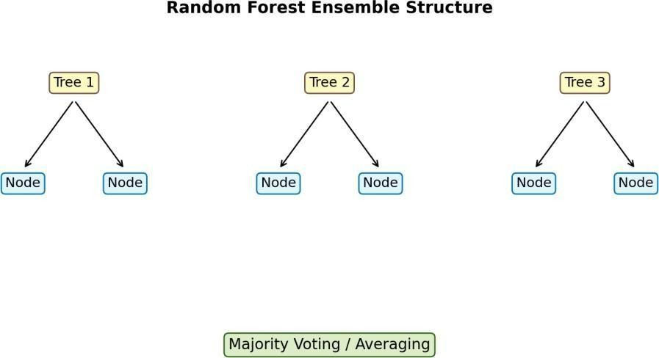

Fig 2.3: Random Forest Structure

Artificial Neural Networks (ANN)

Artificial Neural Networks (ANN) are computational models inspired by the structure
of biological neural systems, consisting of interconnected layers of neurons that process
information through weighted connections and activation functions. ANNs are capable of
learning complex nonlinear relationships between input features and target outputs, making
them highly suitable for modeling intricate systems such as wastewater treatment processes.13
In these systems, multiple parameters interact in nonlinear ways, and ANN can effectively
capture these relationships without requiring explicit mathematical formulations. The
flexibility of ANN allows it to handle high-dimensional data and adapt to varying data
distributions, providing improved prediction accuracy compared to traditional models.
However, standard feedforward ANN architectures do not inherently capture temporal
dependencies, which are essential for time-series forecasting tasks. As wastewater data
exhibits strong sequential patterns and delayed effects, ANN may struggle to model such
behavior effectively without modifications. Additionally, ANN models require careful tuning
of hyperparameters, including the number of layers, neurons, learning rates, and activation
functions, to achieve optimal performance. They are also computationally intensive and may
suffer from issues such as overfitting if not properly regularized. Despite these challenges,
ANN forms the foundation for more advanced deep learning architectures and plays a
significant role in modeling nonlinear relationships within wastewater datasets

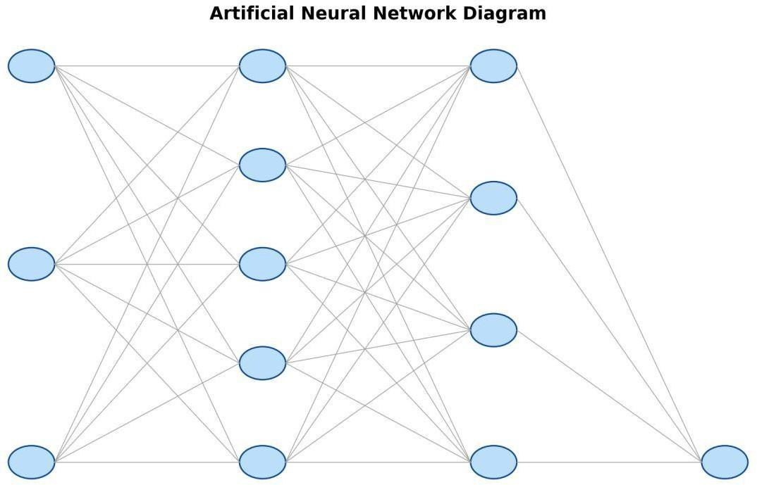

Fig 2.4: Artificial Neural Network Diagram

ARIMA

AutoRegressive Integrated Moving Average (ARIMA) is a classical statistical method used
for time-series forecasting that models a variable based on its own past values, differencing
operations, and past forecast errors. The model is defined by three key parameters representing
the autoregressive component, the degree of differencing required to achieve stationarity, and
the moving average component. In wastewater treatment applications, ARIMA can be used to
predict parameters such as BOD and COD by analyzing historical trends and identifying
temporal patterns. Its strength lies in its strong theoretical foundation and effectiveness in
modeling linear and stationary time-series data. However, real-world wastewater datasets are
often non-stationary and exhibit nonlinear behavior, which limits the effectiveness of ARIMA.
The model struggles to capture complex interactions between multiple variables and requires
extensive preprocessing to transform the data into a stationary form. Additionally, ARIMA is
not well-suited for handling multivariate datasets, where multiple parameters influence each
other simultaneously. As a result, its predictive performance is often inferior compared to
modern machine learning and deep learning approaches when applied to complex
environmental systems. Nevertheless, ARIMA remains a valuable baseline model for time
series analysis and provides a useful comparison for evaluating the performance of more
advanced predictive techniques.

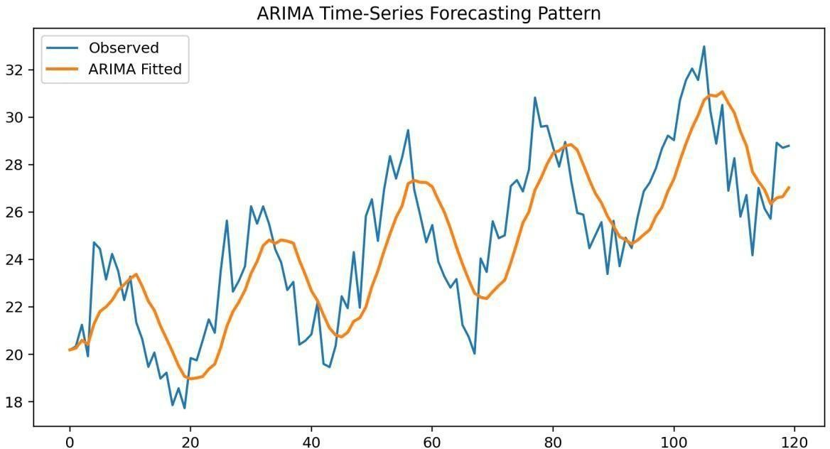

Fig 2.5: ARIMA Time Series Graph

Table 2.1: Comparison of Existing Models

Model | Technique | Accuracy (Typical) | Advantages | Limitations
Linear Regression | Parametric linear fitting | Moderate | Interpretability, low compute | Cannot model strong nonlinearity
KNN | Distance-based instance learning | Moderate | Simple, non- parametric | Sensitive to  scaling and dimensionality
Random Forest | Ensemble decision trees | High | Robust to noise, good generalization | Limited sequential memory
ANN | Feed-forward deep learning | High | Learns nonlinear mappings | Requires tuning and larger data
ARIMA | Statistical time- series model | Moderate-High | Strong for stationary series | Weak for complex non linear multivariate data

Table 2.1 indicates that no single traditional method is universally optimal for all wastewater scenarios. Statistical models provide transparent assumptions but often struggle with nonlinear interactions across multiple water-quality indicators. Distance-based and ensemble methods improve flexibility, yet they do not explicitly encode long temporal memory in the same way sequence models do. Deep learning variants, especially recurrent and attention-augmented networks, offer a stronger balance between representation power and predictive stability for multivariate STP forecasting. These observations motivate the hybrid architecture proposed in this report, where local feature extraction, sequence memory, and adaptive weighting are integrated in one trainable framework.

CHAPTER 3: METHODOLOGY

Data Collection

The foundation of any intelligent prediction system lies in the quality, reliability, and
representativeness of the dataset used for training and evaluation. In the context of wastewater
treatment plants, data collection is a complex and continuous process that involves monitoring
multiple physicochemical and operational parameters over time. In this project, multivariate
time-series data is collected, representing key indicators such as Biochemical Oxygen Demand
(BOD), Chemical Oxygen Demand (COD), Dissolved Oxygen (DO), pH, and other relevant
environmental and operational variables that influence treatment efficiency. These parameters
are recorded at consistent time intervals, typically on a daily basis, ensuring temporal
continuity and enabling the application of sequence-based learning models. The collected
dataset captures the dynamic behavior of wastewater treatment systems, reflecting variations
caused by seasonal changes, rainfall patterns, industrial discharge fluctuations, and operational
disturbances such as equipment inefficiencies or sudden load shocks. Since wastewater
systems are inherently nonlinear and time-dependent, it is essential that the dataset spans a
sufficiently long duration to include both normal operating conditions and extreme events,
allowing the model to generalize effectively across different scenarios. Data acquisition may
involve a combination of automated sensors, laboratory measurements, and historical records,
each contributing to the overall dataset. To ensure data integrity, multiple validation steps are
performed, including range checks to verify that parameter values fall within realistic limits,
consistency checks across correlated variables, and removal of duplicate or corrupted entries.
Additionally, synchronization of timestamps is carried out to align all parameters accurately,
ensuring that each time step represents a coherent snapshot of system conditions. The dataset
is then structured into a unified format suitable for further preprocessing and modeling. By
carefully collecting and validating the data, this stage ensures that the predictive system is
built on a strong and reliable foundation, enabling it to learn meaningful patterns and provide
accurate forecasts that are applicable in real-world wastewater treatment operations.

Data Preprocessing

Missing Value Handling
Data preprocessing is a critical phase in the development of a machine learning model,
particularly for wastewater datasets that are often characterized by noise, missing values,
inconsistencies, and measurement errors.

The primary objective of preprocessing is to convert raw, unstructured data into a clean,
structured, and normalized format that can be effectively utilized by deep learning models. In
this project, preprocessing involves several sequential steps, including data cleaning, missing
value handling, outlier detection and treatment, normalization, and transformation into a
supervised learning format. Since wastewater data is collected from real-world environments,
it is susceptible to irregularities caused by sensor malfunctions, calibration errors, or manual
recording inconsistencies. If left unaddressed, these issues can significantly degrade model
performance by introducing bias or misleading patterns. Therefore, preprocessing ensures that
such anomalies are identified and handled appropriately. Another important aspect of
preprocessing is ensuring consistency across different features, as parameters such as BOD,
COD, DO, and pH are measured on different scales and units. Without proper scaling, features
with larger numerical ranges can dominate the learning process, leading to suboptimal model
performance. Additionally, preprocessing enhances the stability of the training process by
reducing variance and ensuring that input data is well-conditioned for gradient-based
optimization algorithms. Temporal alignment is also maintained during preprocessing to
preserve the sequential nature of the dataset, which is essential for time-series modeling. The
preprocessing pipeline is designed to be systematic and reproducible, ensuring that the same
transformations can be applied consistently during both training and inference stages. By
carefully preparing the dataset, this stage lays the groundwork for effective feature extraction,
model training, and accurate prediction, ultimately improving the robustness and reliability of
the overall system.
3.2.2 Outlier Removal Using IQR
OutlierhandlingfollowstheInterquartileRange(IQR)principle. For eachfeature, Q1andQ3
are computed and the IQR is defined as IQR = Q3 -Q1. Points lying outside [Q1 -1.5*IQR,
Q3 + 1.5*IQR] are treated as potential outliers. Instead of aggressive deletion, outlier
management in this project is context-aware and bounded by realistic process ranges so that
trueprocessexcursionsarenotmistakenlyremoved.Thisstepreducesdistortioninscalingand
gradient updates during training.
3.2.3 Normalization
NormalizationusesMin-Maxscalingtomapeachfeatureintoacomparablenumericalinterval.
Thetransformationisgivenbyx'=(x-xmin)/(xmax-xmin).Thispreservesrelativeordering
whilereducing magnitude imbalanceacross features. Because neuraloptimizationis sensitive
to scale, normalizedinputs improveconvergencespeedandstabilizelossdescent,particularly
when combining parameters measured in different physical units such as mg/L and pH.

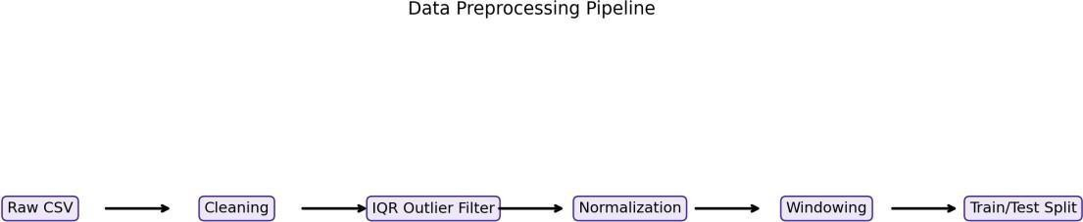

Fig 3.1: Data Preprocessing Pipeline
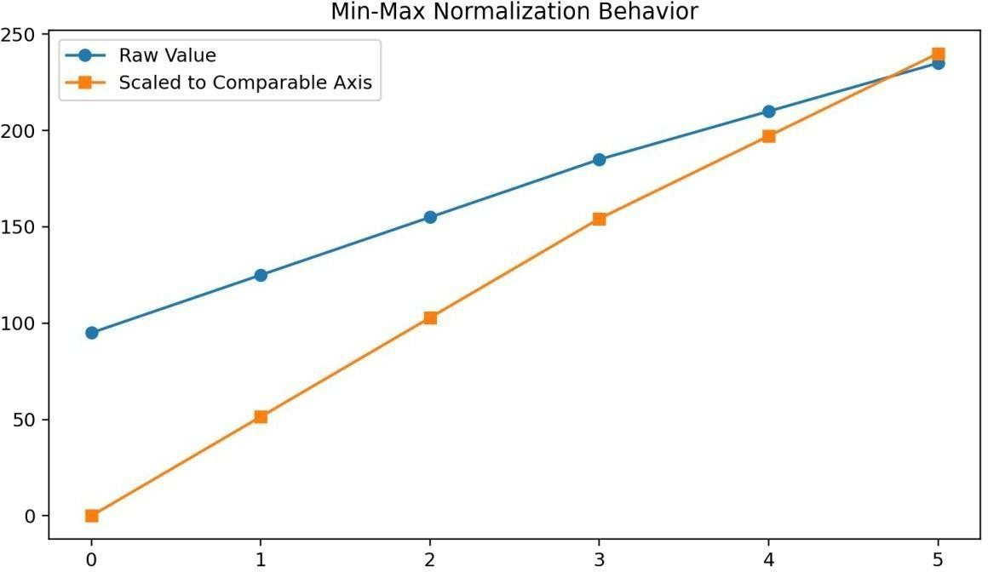

Fig 3.2: Data Normalization Graph

Time-Series Windowing
Time-series windowing is a fundamental step in preparing sequential wastewater data for
supervised learning, enabling the model to learn temporal dependencies by mapping historical
observations to future predictions. In wastewater treatment systems, current parameter values
are strongly influenced by past states due to biological processes, chemical reactions, and
hydraulic retention effects, which introduce time-lag behavior across variables such as BOD,
COD, DO, and pH.

To capture these dependencies effectively, the raw time-series data is transformed into input-
output pairs using a sliding window approach. In this method, a fixed-length sequence of past
observations, referred to as the input window, is used to predict the value at the next time step
or a set of future time steps. For example, a window size of 30 implies that the model uses the
previous 30 days of data to predict the parameter value for the 31st day. This transformation
converts the dataset into a structured format suitable for training deep learning models such as
CNN and LSTM, which require fixed-size input sequences. The sliding window moves
sequentially across the dataset, generating multiple overlapping samples that increase the
effective size of the training data and improve model generalization. Additionally, this
approach preserves the chronological order of observations, ensuring that the model learns
realistic temporal relationships without violating causality. The choice of window size is
critical, as smaller windows may fail to capture long-term dependencies, while excessively
large windows may introduce noise and increase computational complexity. Therefore, the
window size is selected based on domain knowledge and experimental validation to balance
performance and efficiency. Time-series windowing also enables the model to capture gradual
trends, seasonal patterns, and abrupt fluctuations, which are characteristic of wastewater
systems. By structuring the data in this manner, the model is equipped to learn both short-term
dynamics and long-term behavior, resulting in more accurate and reliable predictions that
reflect real-world operational conditions.
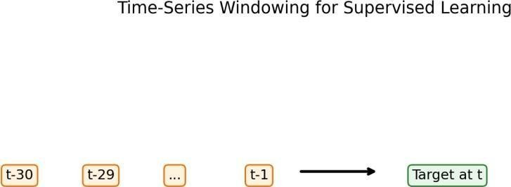

Fig 3.3: Time Series Windowing

Model Architecture
The model architecture proposed in this project is a hybrid deep learning framework that
integrates Convolutional Neural Networks (CNN), Long Short-Term Memory (LSTM)
networks, and an Attention mechanism to effectively capture complex patterns in multivariate
time-series wastewater data. The motivation behind this hybrid design is to combine the
strengths of different neural network components, each addressing a specific aspect of the
prediction problem. Wastewater treatment processes exhibit both local temporal patterns and
long-range dependencies, along with varying importance of different time steps, making it
necessary to adopt a multi-component architecture capable of handling these characteristics
simultaneously. The CNN component is responsible for extracting local temporal features
from the input sequences, identifying short-term patterns and trends within the data. The
LSTM component builds upon these features by capturing long-term dependencies and
sequential relationships, ensuring that the model retains relevant historical information over
extended periods. The Attention mechanism further enhances the model by assigning dynamic
weights to different time steps, allowing it to focus on the most informative parts of the
sequence during prediction.

CNN Module
The Convolutional Neural Network (CNN) module plays a crucial role in extracting local
temporal features from the input time-series data, enabling the model to identify short-term
patterns and variations in wastewater parameters. Unlike traditional fully connected networks,
CNN applies convolutional filters that slide across the input sequence, capturing localized
patterns such as sudden spikes, gradual increases, or periodic fluctuations. In the context of
wastewater treatment, these local patterns may correspond to short-term changes in influent
composition, operational adjustments, or environmental influences. The convolution operation
involves applying multiple filters to the input data, each learning a specific feature
representation, resulting in a set of feature maps that highlight important patterns. Activation
functions such as ReLU are applied to introduce nonlinearity, allowing the model to capture
complex relationships within the data. Pooling layers may also be used to reduce
dimensionality and improve computational efficiency while retaining essential information.
The CNN module effectively transforms raw input sequences into a richer and more
informative representation, which is then passed to the subsequent LSTM layers for further
processing. By focusing on local feature extraction, the CNN component enhances the model
’s ability to detect subtle variations and noise-resistant patterns, contributing to improved
prediction performance.
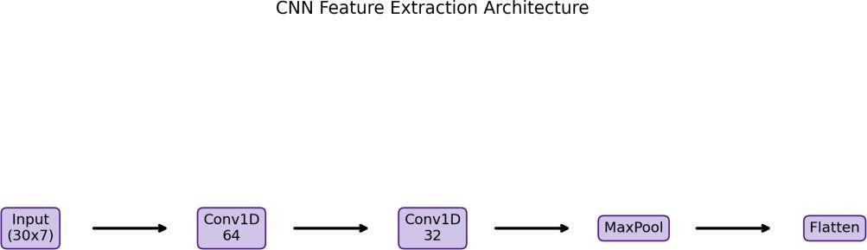

Fig 3.4: CNN Architecture Diagram

LSTM Module
The Long Short-Term Memory (LSTM) module is specifically designed to capture long-term
dependencies and sequential relationships in time-series data, making it a critical component of
the proposed model. Unlike traditional recurrent neural networks, LSTM addresses the problem
of vanishing gradients through the use of gated mechanisms that regulate the flow of
information across time steps. These gates include the input gate, forget gate, and output gate,
each controlling how information is added, retained, or discarded within the memory cell. In
wastewater treatment systems, where the effect of changes in one parameter may be observed
after a delay, LSTM is particularly effective in modeling such temporal dependencies. The
LSTM layer processes the sequence of feature representations generated by the CNN module,
learning patterns that span across multiple time steps and capturing both short-term fluctuations
and long-term trends. By maintaining a memory of past states, the LSTM module enables the
model to make informed predictions based on historical context. This is essential for accurately
forecasting parameters that are influenced by cumulative effects, such as biological processes
in treatment plants. The ability of LSTM to handle sequential data and retain relevant
information over time makes it a powerful tool for time-series prediction tasks, significantly
enhancing the overall performance of the model.

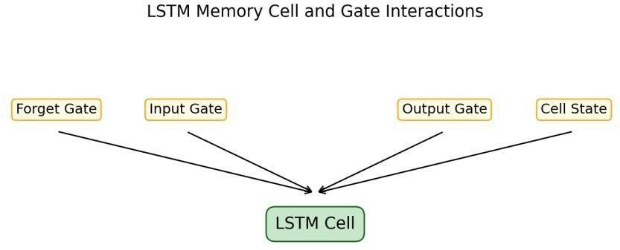

Fig 3.5: LSTM Cell Structure

Attention Mechanism
The Attention mechanism is an advanced component that enhances the model’s ability to
focus on the most relevant parts of the input sequence during prediction. In time-series data,
not all time steps contribute equally to the prediction of future values, and some observations
may carry more significance than others. The Attention mechanism addresses this by
assigning weights to different time steps, allowing the model to prioritize important
information while reducing the influence of less relevant data. This is particularly useful in
wastewater systems, where certain events such as sudden load increases or operational
changes may have a stronger impact on future conditions. The Attention layer computes a
context vector by combining the outputs of the LSTM layer, weighted by their importance
scores. This context vector serves as a refined representation of the input sequence, capturing
the most informative features for prediction. By dynamically adjusting the importance of
different time steps, the Attention mechanism improves both prediction accuracy and
interpretability, as it provides insights into which parts of the sequence are most influential.
This makes the model more transparent and easier to analyze, which is valuable in engineering
applications where understanding model behavior is important.

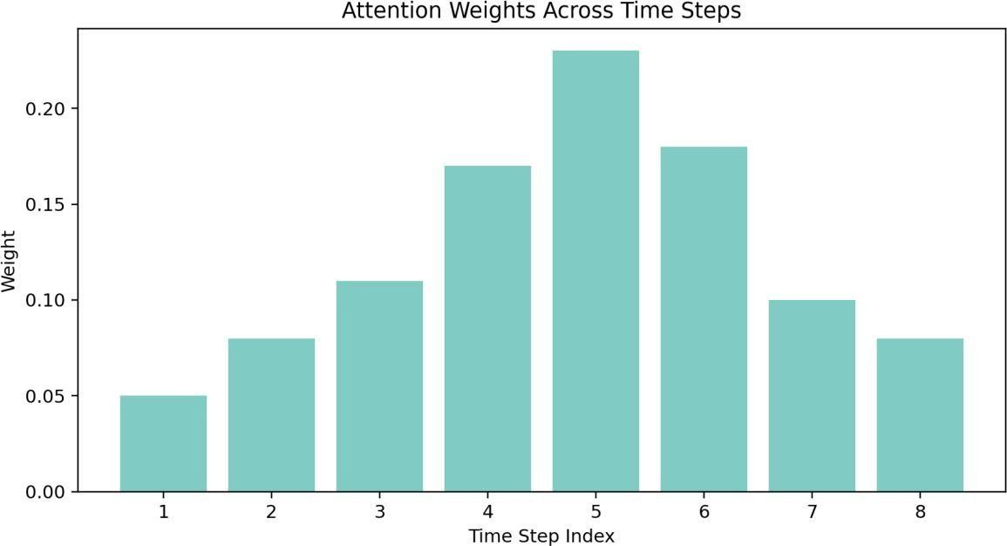

Fig 3.6: Attention Mechanism Visualization

Integrated CNN-LSTM-Attention Network
The integration of CNN, LSTM, and Attention components results in a comprehensive hybrid
architecture that leverages the strengths of each individual module to address the complexities
of wastewater prediction. The CNN layer extracts local temporal features, the LSTM layer
captures sequential dependencies, and the Attention mechanism highlights the most relevant
information, creating a unified framework capable of modeling complex nonlinear
relationships. The flow of data through the network begins with the input sequence, which is
processed by the CNN layer to generate feature maps. These feature maps are then passed to
the LSTM layer, where temporal dependencies are learned and encoded into a sequence of
hidden states. The Attention mechanism is applied to these hidden states to compute a
weighted representation, which is then fed into fully connected layers for final prediction. This
layered approach ensures that the model captures both micro-level patterns and macro-level
trends, resulting in highly accurate predictions.

The hybrid architecture is particularly effective in handling multivariate time-series data,
where multiple parameters interact in complex ways. By combining different learning
mechanisms, the model achieves better generalization and robustness compared to individual
models. This integrated design represents a significant advancement over traditional
approaches, providing a powerful solution for intelligent wastewater quality prediction.

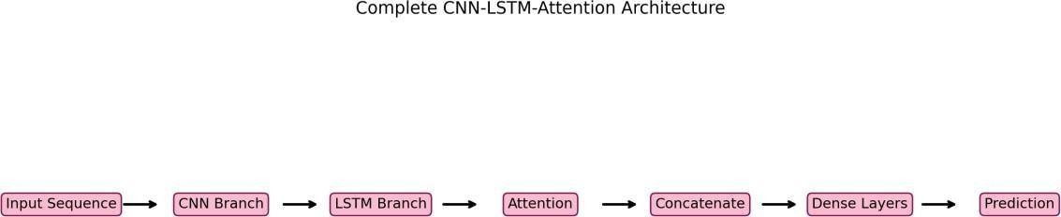

Fig 3.7: Complete CNN-LSTM-Attention Model

Training Setup
The model is trained with the Adam optimizer to balance adaptive learning-rate control and stable convergence behavior in nonlinear loss landscapes. Mean Squared Error (MSE) is selected as the objective function because it penalizes large deviations and directly aligns with regression reliability. The training schedule uses 100 epochs, batch size 32, early stopping with patience 15, and reduce-on-plateau learning-rate scheduling. This combination supports convergence while avoiding unnecessary over-training.

Table 3.1: Model Hyperparameters

Parameter | Value
Input Window Size | 30 time steps
Input Features | 7
Conv1D Filters | 64, 32
LSTM Units | 64, 32
Dense Layers | 64 -> 32 -> 16 -> 1
Optimizer | Adam
Loss | MSE
Epochs | 100
Batch Size | 32
Early Stopping Patience | 15

The training setup defines the process through which the model learns from data and
optimizes its parameters to achieve accurate predictions. In this project, the model is trained
using the Adam optimizer, which is widely used for its ability to adapt learning rates
dynamically and achieve faster convergence in complex optimization problems. The loss
function selected for training is Mean Squared Error (MSE), which measures the average
squared difference between predicted and actual values, penalizing larger errors more heavily
and ensuring accurate regression performance. The training process is conducted over multiple
epochs, allowing the model to iteratively refine its parameters based on the training data. A
batch size of 32 is used to balance computational efficiency and learning stability. Early
stopping is implemented to prevent overfitting, where training is halted if the validation loss
does not improve for a specified number of epochs. Additionally, learning rate scheduling is
applied to reduce the learning rate when the model reaches a plateau, enabling finer
adjustments during later stages of training. The dataset is divided into training, validation, and
testing subsets to evaluate model performance at different stages and ensure generalization to
unseen data. During training, various performance metrics such as RMSE, MAE, R², and
MAPE are monitored to assess prediction accuracy and model behavior.

Visualization techniques such as loss curves and prediction plots are also used to analyze
training dynamics and identify potential issues. This comprehensive training setup ensures that
the model learns effectively, avoids overfitting, and achieves reliable performance, making it
suitable for real-world deployment in wastewater treatment systems.

CHAPTER 4: RESULTS AND ANALYSIS

Evaluation Metrics
The performance of the proposed CNN-LSTM-Attention model is evaluated using multiple regression metrics to provide a comprehensive assessment of prediction accuracy, error distribution, and model reliability under realistic wastewater conditions. Each evaluation metric captures a different aspect of model performance, ensuring that the analysis is both quantitative and interpretable from an engineering perspective. Root Mean Squared Error (RMSE) is used to measure the magnitude of prediction errors, with a higher penalty assigned to larger deviations, making it particularly useful in wastewater systems where extreme errors can lead to operational risks. Mean Absolute Error (MAE) provides a direct measure of average error magnitude in the original units of the parameters, offering intuitive interpretation of prediction accuracy. The coefficient of determination (R²) evaluates how well the model explains the variance in the observed data, indicating the strength of correlation between predicted and actual values. Mean Absolute Percentage Error (MAPE) expresses prediction error as a percentage, allowing comparison across parameters with different scales. Together, these metrics provide a balanced evaluation framework that captures both absolute and relative performance. In addition to numerical metrics, visual analysis techniques such as prediction plots, residual distributions, and scatter diagrams are used to assess model behavior and identify potential biases or systematic errors. This multi-dimensional evaluation approach ensures that the model is not only accurate but also stable, reliable, and suitable for real-world deployment in wastewater treatment systems.

Dissolved Oxygen (DO) Analysis
Dissolved Oxygen (DO) is a critical parameter in wastewater treatment processes, as it directly influences biological activity and aeration efficiency within the system. Accurate prediction of DO levels is essential for maintaining optimal treatment conditions and preventing issues such as oxygen depletion or excessive aeration energy consumption. The results obtained from the CNN-LSTM-Attention model demonstrate a strong ability to capture the temporal dynamics of DO variations, including gradual trends and short-term fluctuations. The prediction curve closely follows the actual observed values, indicating that the model effectively learns underlying patterns in the data. Minor smoothing effects are observed in the predictions, which can be attributed to the model’s effort to generalize rather than overfit to noise. Residual analysis reveals that errors are centered around zero with moderate dispersion, suggesting that the model does not exhibit significant bias and maintains consistent performance across different value ranges. The scatter plot further confirms a strong correlation between predicted and actual values, with most data points aligning near the diagonal reference line. However, slight deviations are observed in extreme conditions, indicating potential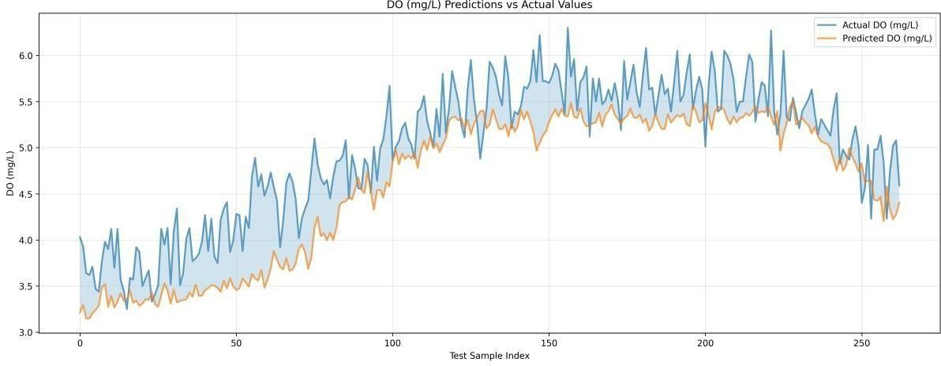
Fig 4.1: DO Predictions vs Actual
The prediction curve for DO follows the true trajectory with acceptable smoothing, indicating that the model captures dominant operational rhythms and short-term process drift.
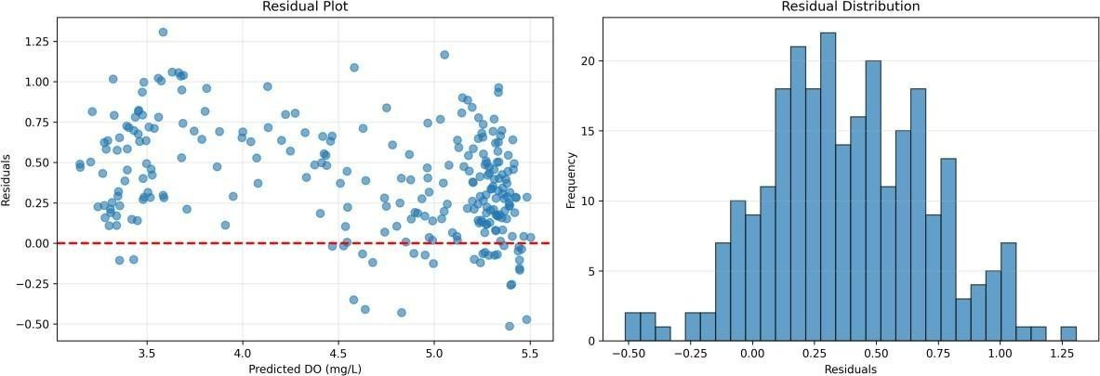

Fig 4.2: DO Residual Plot
Residual dispersion remains centered with moderate spread, suggesting manageable error variance and no severe systematic bias across the observed range.

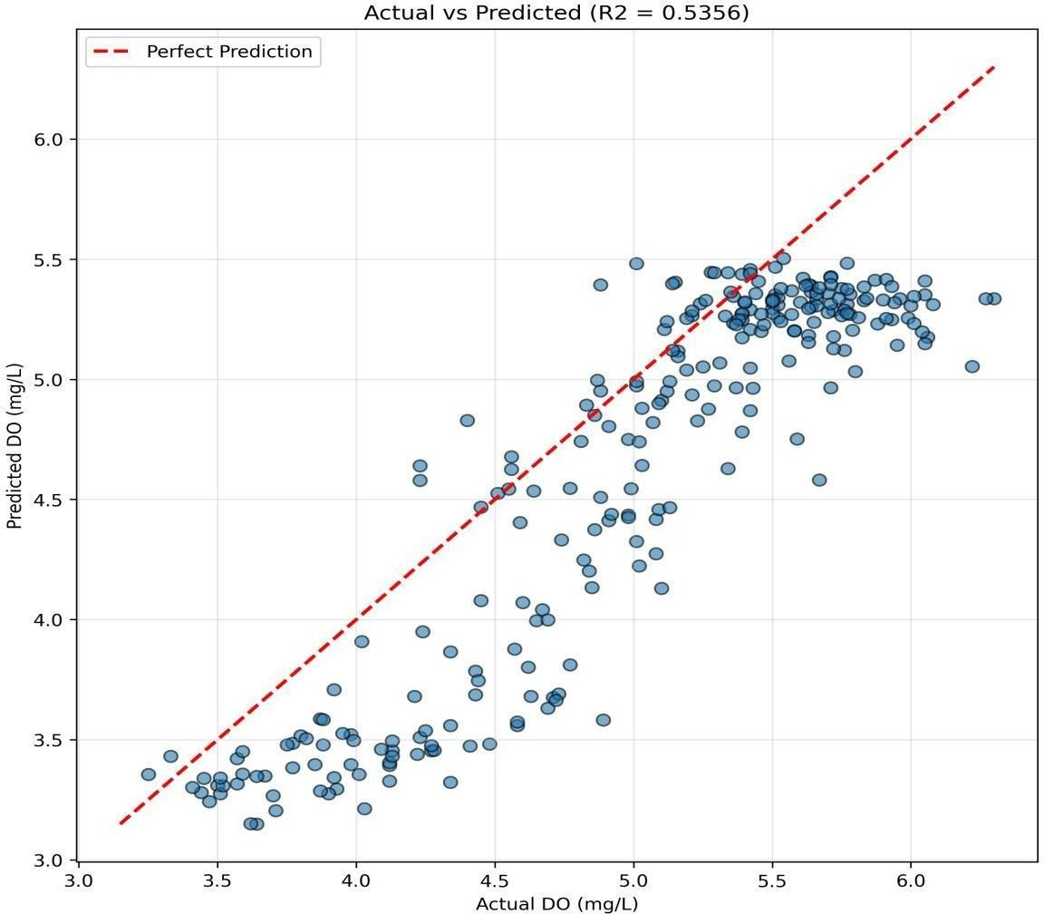

Fig 4.3: DO Scatter Plot
The scatter alignment around the diagonal confirms useful correlation, although outer-region variance reveals opportunities for calibration under extreme conditions.

pH Analysis
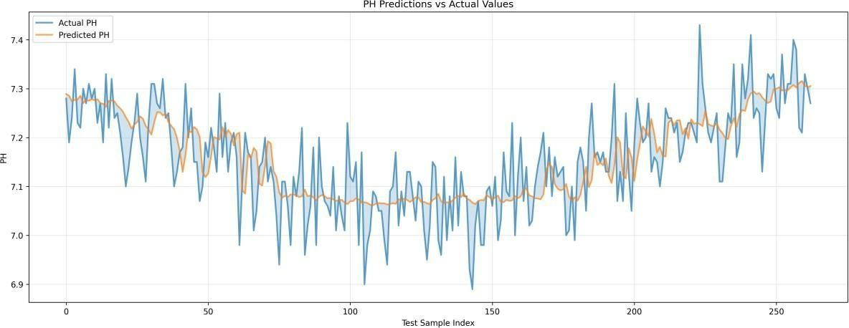
The prediction of pH levels in wastewater treatment systems is particularly challenging due to the narrow operating range and sensitivity of pH to small changes in chemical composition. Despite these challenges, the proposed model achieves stable and consistent performance in predicting pH values. The prediction curve closely tracks the actual data, reflecting the model’s ability to capture subtle variations within a constrained range. Unlike parameters such as BOD and COD, which exhibit larger variability, pH values tend to remain within a limited interval, making traditional evaluation metrics such as R² less sensitive to performance differences. Residual analysis shows that errors are tightly distributed around zero with minimal spread, indicating high precision and low variability in predictions. The scatter plot demonstrates a strong clustering of points near the diagonal line, confirming a high degree of correlation between predicted and actual values. The model’s ability to maintain stability in pH prediction is particularly important, as even small deviations can impact treatment efficiency and compliance with discharge standards. The results indicate that the hybrid architecture effectively captures the underlying chemical dynamics governing pH behavior, making it suitable for monitoring and control applications in wastewater treatment systems.
Fig 4.4: pH Predictions vs Actual
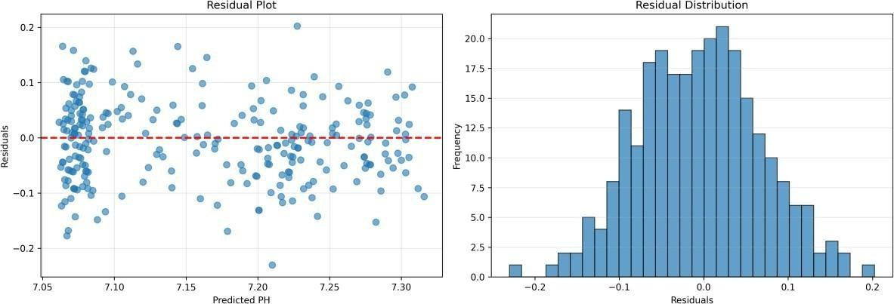
The pH prediction profile is stable and closely tracks central dynamics, reflecting the model's ability to represent bounded variations in near-neutral operating bands.

Fig 4.5: pH Residual Plot
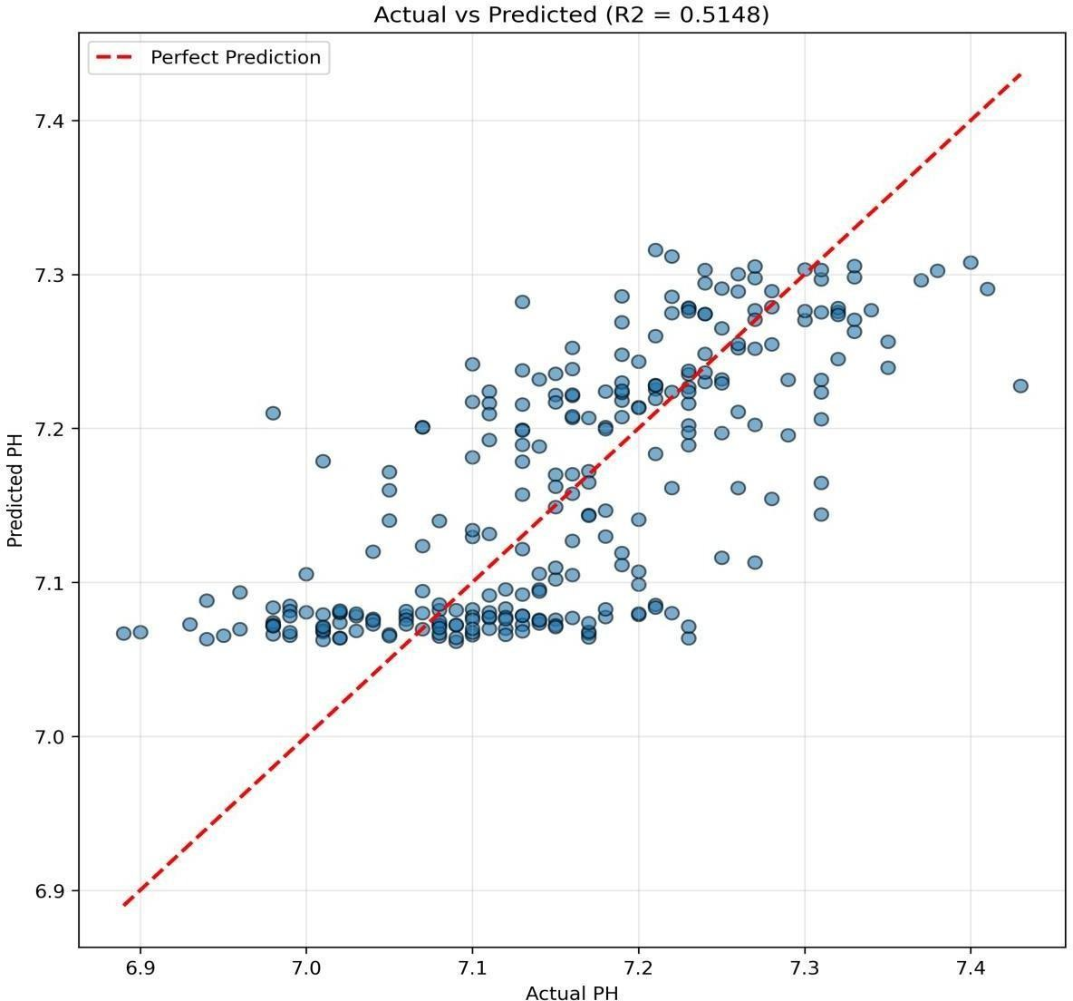

Fig 4.6: pH Scatter Plot
The cluster concentration near the reference diagonal indicates dependable correlation despite reduced R2 sensitivity caused by narrow response variance.

BOD Analysis

Biochemical Oxygen Demand (BOD) is a key indicator of organic pollution in wastewater and plays a crucial role in assessing treatment efficiency and regulatory compliance. The results of the proposed model show strong performance in predicting BOD values, with the prediction curve closely following the actual trend. The model successfully captures both gradual changes and significant peaks in BOD levels, demonstrating its ability to learn complex patterns associated with organic load variations. Compared to other parameters, BOD exhibits higher variability, making accurate prediction more challenging. However, the hybrid CNN-LSTM-Attention architecture effectively handles this complexity by combining local feature extraction, temporal memory, and attention-based weighting. Residual analysis indicates that errors are generally unbiased, with occasional underestimation during sharp peaks, which may be attributed to sudden changes in influent composition. The scatter plot shows a high degree of alignment along the diagonal, confirming strong predictive accuracy and correlation. The high R² value further supports the model’s effectiveness in explaining variance in BOD data. These results highlight the model’s capability to provide reliable predictions for organic load monitoring, enabling proactive decision-making and improved treatment efficiency.

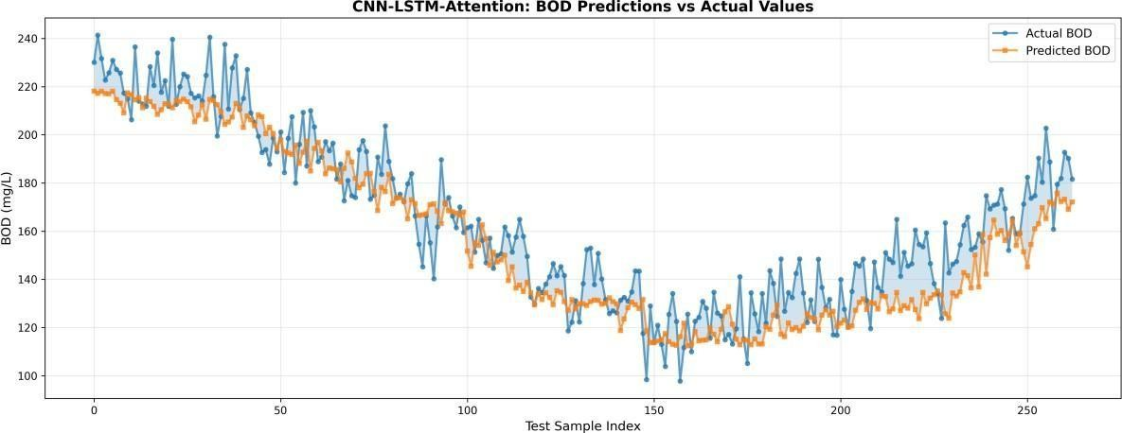

Fig 4.7: BOD Predictions vs Actual
BOD prediction demonstrates strong trend adherence and comparatively lower error spread, highlighting effective learning of organic loading patterns.

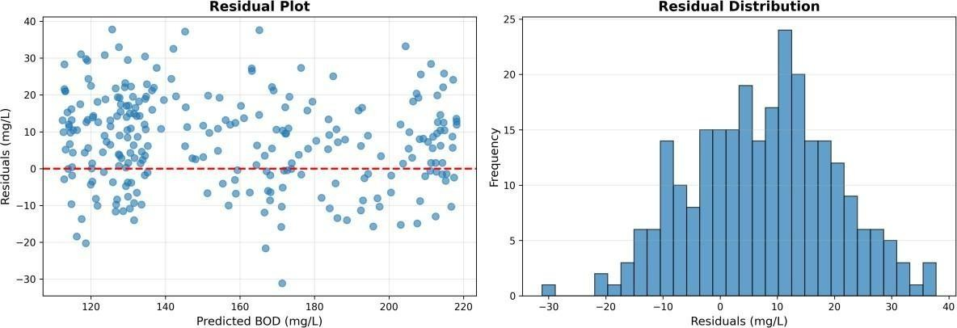

Fig 4.8: BOD Residual Plot
Residual characteristics indicate largely unbiased estimation with occasional peak underestimation during abrupt changes in influent profile.
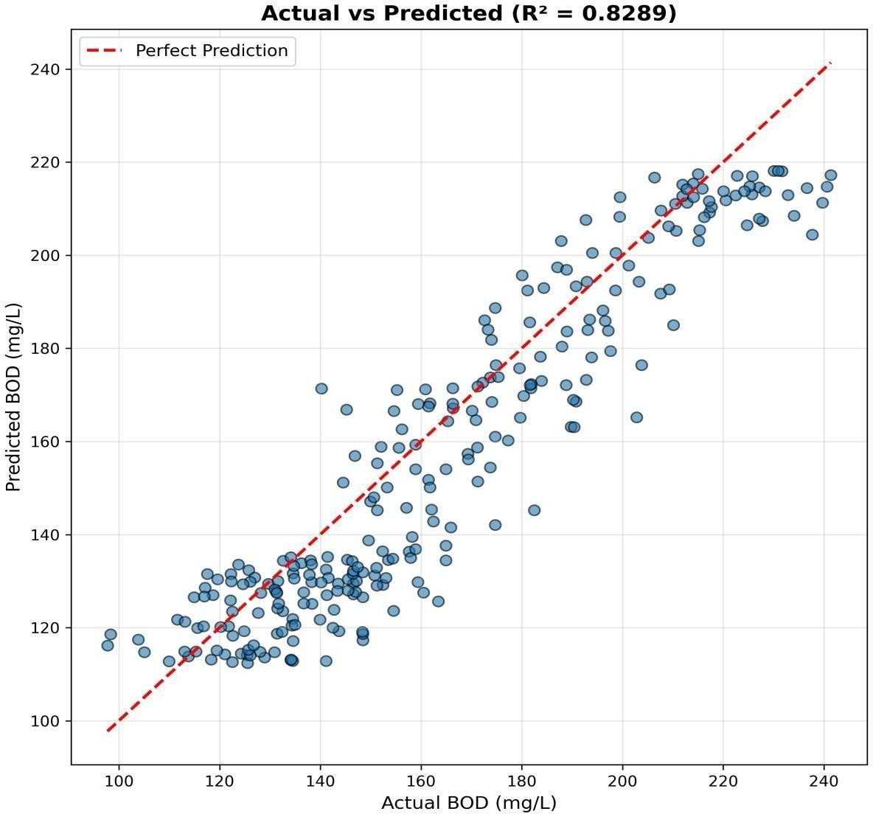

Fig 4.9: BOD Scatter Plot

The scatter plot demonstrates high correlation and strong explanatory behavior, consistent with the superior R2 performance for this target.

COD Analysis
Chemical Oxygen Demand (COD) represents the total amount of oxygen required to oxidize organic and inorganic substances in wastewater, making it an important parameter for assessing pollutant load. The proposed model demonstrates strong performance in COD prediction, with the prediction curve effectively capturing both baseline trends and significant fluctuations. The model’s ability to handle multiscale temporal patterns is evident from its performance in tracking both gradual changes and sudden peaks in COD levels. Residual analysis shows that errors are centered around zero, with slightly wider dispersion compared to parameters like pH, reflecting the higher variability and complexity of COD data. The scatter plot indicates strong correlation, with most data points clustered along the diagonal line, confirming accurate prediction. The high R² value further validates the model’s ability to explain variance in COD data, making it one of the best-performing parameters in the study. The results demonstrate that the hybrid architecture effectively captures the nonlinear relationships and temporal dependencies associated with pollutant load, providing valuable insights for process optimization and compliance monitoring in wastewater treatment plants.

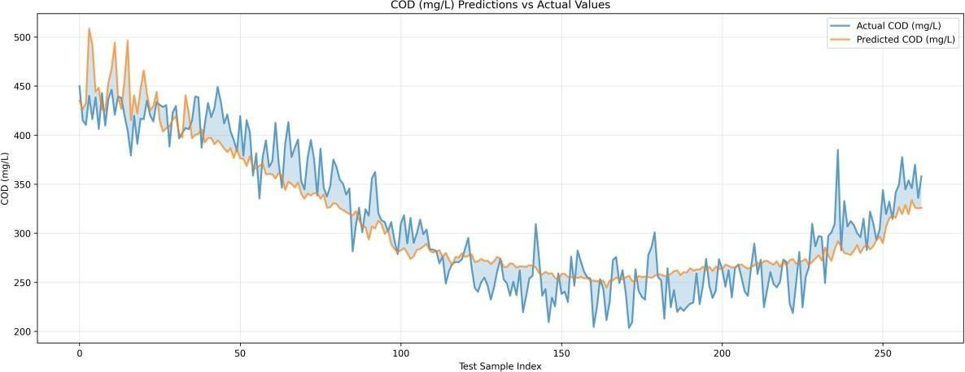

Fig 4.10: COD Predictions vs Actual
COD predictions preserve both baseline movement and major peaks, demonstrating that the hybrid architecture captures multiscale temporal structure.
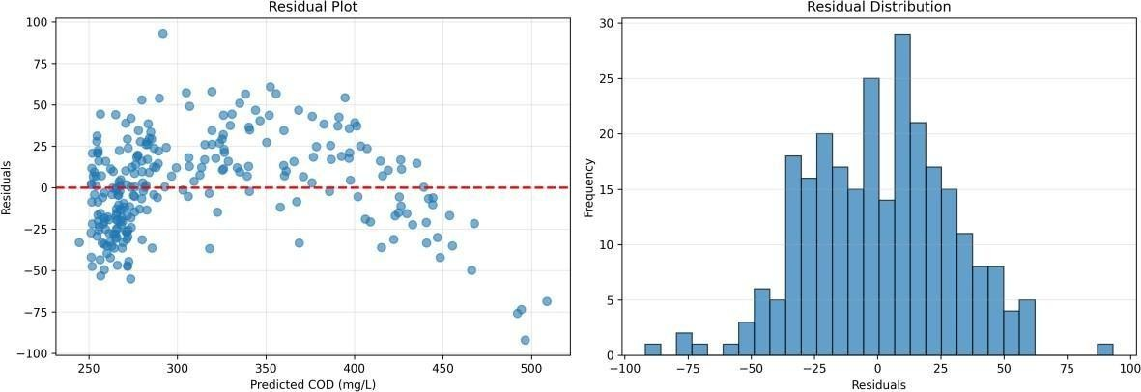

Fig 4.11: COD Residual Plot
Residual analysis reveals centered errors with wider tails than pH, reflecting natural complexity and larger value range of COD measurements.

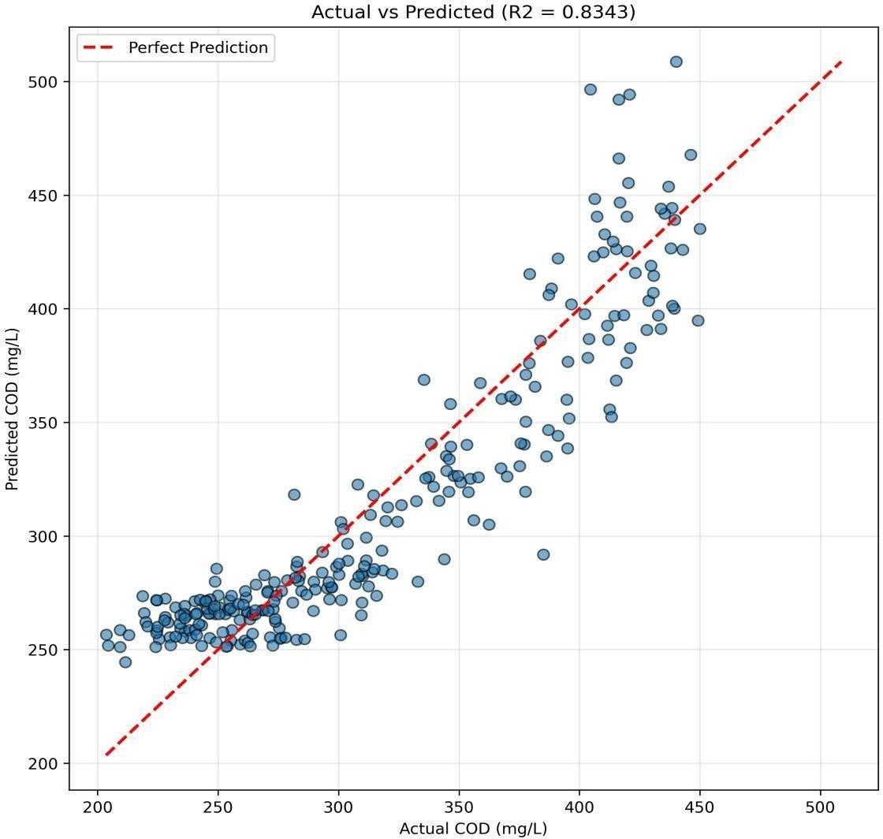

Fig 4.12: COD Scatter Plot
Diagonal clustering remains strong, confirming robust predictive performance for COD and validating suitability for plant-level operational guidance.

Training Dynamics
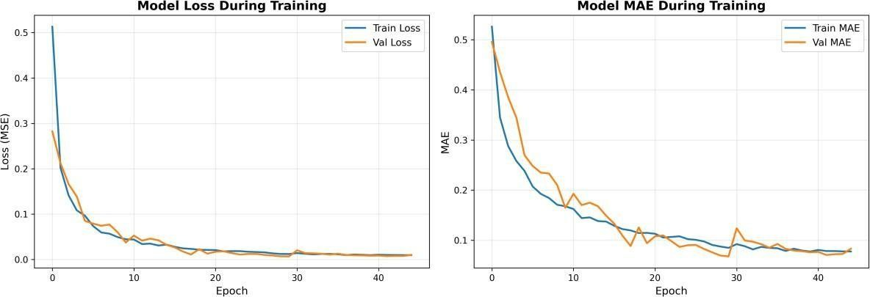
Fig 4.13: Training Loss Curve

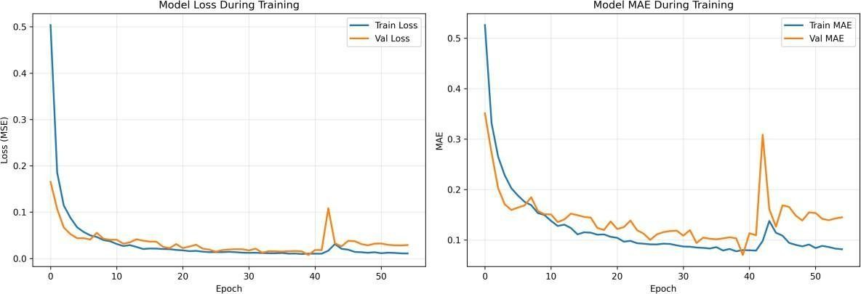

Fig 4.14: Model Accuracy Curve

Parameter | RMSE | MAE | R2 | MAPE (%)
DO | 0.5045 | 0.4189 | 0.5356 | 8.5569
pH | 0.0725 | 0.0583 | 0.5148 | 0.8159
BOD | 14.4834 | 11.8191 | 0.8289 | 7.3658
COD | 28.3680 | 22.9936 | 0.8343 | 7.5561

Table 4.1: Performance Metrics
The training dynamics of the model provide insights into its learning behavior, convergence characteristics, and generalization capability. The training loss curve shows a consistent decrease over epochs, indicating that the model effectively learns patterns from the data and minimizes prediction error. The validation loss follows a similar trend, suggesting that the model does not suffer from significant overfitting and maintains good generalization performance. The use of early stopping prevents excessive training, ensuring that the model stops at an optimal point where performance on unseen data is maximized. The accuracy curve further illustrates stable improvement during training, reflecting effective optimization of model parameters. The performance metrics obtained for different parameters show that BOD and COD achieve the highest R² values, indicating strong predictive capability for parameters with higher variability. In contrast, DO and pH exhibit slightly lower R² values due to their constrained ranges and sensitivity to small fluctuations. Despite these differences, all parameters demonstrate consistent prediction accuracy and stable error behavior. The combination of numerical metrics and visual analysis confirms that the model achieves a balanced trade-off between accuracy and generalization, making it suitable for real-world wastewater prediction applications. Overall, the training dynamics validate the effectiveness of the proposed architecture and its ability to deliver reliable performance across multiple parameters.

CHAPTER 5: CONCLUSION
The successful development and evaluation of the Smart STP Prediction System using the CNN-LSTM-Attention model demonstrate the effectiveness of integrating deep learning techniques for intelligent wastewater quality forecasting. Wastewater treatment processes are inherently complex, involving dynamic interactions between multiple physicochemical parameters that vary over time due to environmental, operational, and biological factors. Traditional monitoring approaches are often reactive and limited in their ability to capture these complexities in real time. This project addresses these limitations by proposing a data-driven predictive framework capable of modeling nonlinear relationships, temporal dependencies, and inter-parameter interactions in wastewater datasets. The use of a hybrid architecture combining Convolutional Neural Networks, Long Short-Term Memory networks, and Attention mechanisms enables the model to extract local patterns, retain long-term temporal information, and focus on the most relevant features during prediction, resulting in improved accuracy and robustness.
The experimental results confirm that the proposed model performs effectively across multiple parameters, including Dissolved Oxygen, pH, Biochemical Oxygen Demand, and Chemical Oxygen Demand. The evaluation metrics indicate strong predictive capability, particularly for parameters with higher variability such as BOD and COD, where the model achieves high R² values and consistent trend alignment. Even for parameters with constrained ranges such as pH and DO, the model demonstrates stable performance and low error distribution, highlighting its ability to handle diverse data characteristics. The combination of numerical evaluation and visual analysis, including prediction curves, residual plots, and scatter diagrams, provides comprehensive validation of model performance and confirms its suitability for real-world applications.
A key strength of this work lies in the preservation of time-series structure through sliding window techniques, allowing the model to learn realistic temporal behavior and capture delayed effects commonly observed in wastewater treatment processes. Additionally, the preprocessing pipeline, including missing value handling, outlier treatment, and normalization, ensures that the input data is clean, consistent, and suitable for deep learning. The integration of these steps into a unified framework results in a reliable and efficient prediction system that can support operational decision-making. By enabling accurate forecasting of key parameters, the system provides valuable insights for early warning, process optimization, and regulatory compliance, contributing to improved efficiency and sustainability in wastewater treatment plants.
Furthermore, the deployment aspect of the project, involving the integration of a FastAPI backend and a user-friendly interface, demonstrates the practical applicability of the proposed system beyond theoretical modeling. This end-to-end approach bridges the gap between research and real-world implementation, highlighting the potential of intelligent systems in modern infrastructure management. The ability to process input data, generate predictions, and present results in an accessible format makes the system suitable for adoption in smart wastewater management frameworks.
In conclusion, this project successfully demonstrates that hybrid deep learning models can significantly enhance the accuracy and reliability of wastewater quality prediction. The proposed CNN-LSTM-Attention architecture effectively addresses the challenges of nonlinear, multivariate, and time-dependent data, providing a robust solution for intelligent monitoring and forecasting. The outcomes of this work contribute to the advancement of smart environmental systems and lay the foundation for future developments in AI-driven wastewater management, supporting the transition toward more sustainable and data-driven urban infrastructure.

FUTURE WORK
The proposed Smart STP Prediction System establishes a strong foundation for intelligent wastewater monitoring; however, there are several opportunities for further enhancement to improve scalability, adaptability, and real-world applicability. One of the most significant directions for future work is the integration of Internet of Things (IoT) sensor networks to enable real-time data acquisition and continuous monitoring of wastewater parameters. By connecting sensor gateways directly to the prediction system, it becomes possible to stream live data into the model, allowing instant forecasting and early detection of abnormal conditions. This real-time capability can significantly enhance operational responsiveness and reduce the risk of process failure or regulatory violations.
Another important area of improvement is the deployment of the system using cloud-native technologies to support scalable and distributed operations across multiple wastewater treatment plants. By leveraging cloud platforms and container orchestration tools, the model can be deployed as a service that handles large volumes of data from different locations simultaneously. This enables centralized monitoring and management while maintaining flexibility and scalability. Additionally, implementing adaptive retraining pipelines with concept drift detection can ensure that the model remains accurate over time, even as system conditions evolve. Automated model updating and governance mechanisms can be introduced to maintain performance without requiring manual intervention.
Future enhancements can also include the incorporation of additional contextual variables such as meteorological data, including temperature, rainfall, and humidity, as well as hydraulic parameters like flow rate and retention time. These factors play a significant role in influencing wastewater characteristics and can provide valuable insights for improving prediction accuracy. By expanding the feature space, the model can develop a more comprehensive understanding of system behavior and produce more reliable forecasts under varying environmental conditions.
The development of a more advanced user interface is another important direction for future work. Expanding the existing mobile and web-based applications to include interactive dashboards, real-time alerts, and detailed analytics can improve usability and decision-making. Features such as multilingual support, customizable notifications, and visual trend analysis can make the system more accessible to operators and stakeholders with different levels of technical expertise. Additionally, implementing role-based access control and secure API management will enhance system security and enable enterprise-level deployment in large-scale industrial environments.
Explainable Artificial Intelligence (XAI) is another promising area for future research, as it can improve transparency and trust in model predictions. By incorporating interpretability techniques such as feature importance visualization and attention weight analysis, operators can better understand how predictions are generated and make informed decisions based on model outputs. This is particularly important in wastewater treatment systems, where human intervention may be required in critical situations.
Furthermore, advanced deep learning architectures such as Transformer models and hybrid attention-based networks can be explored to further improve prediction performance. These models have shown strong capabilities in handling long-range dependencies and complex sequence relationships, which are highly relevant in wastewater time-series data. Hyperparameter optimization and automated machine learning (AutoML) techniques can also be applied to fine-tune model performance and identify optimal configurations.
In addition, integrating the system with smart city infrastructure can enable broader applications in urban water management, including predictive maintenance, resource optimization, and environmental monitoring. The use of edge computing can also be explored to perform real-time inference directly at the source, reducing latency and improving efficiency. These advancements will contribute to the development of a fully autonomous and intelligent wastewater management system.
In conclusion, the future scope of this project lies in transforming the current prediction system into a comprehensive, scalable, and intelligent platform that integrates real-time data acquisition, advanced analytics, and user-centric design. By incorporating these enhancements, the system can evolve into a powerful tool for smart wastewater management, supporting sustainable urban development and efficient resource utilization.

REFERENCES
- Metcalf & Eddy, Inc. (2014). Wastewater Engineering: Treatment and Resource Recovery. McGraw-Hill Education.
- Hochreiter, S., & Schmidhuber, J. (1997). Long Short-Term Memory. Neural Computation, 9(8), 1735-1780.
- Vaswani, A., et al. (2017). Attention Is All You Need. Advances in Neural Information Processing Systems.
- Goodfellow, I., Bengio, Y., & Courville, A. (2016). Deep Learning. MIT Press.
- Box, G. E. P., Jenkins, G. M., Reinsel, G. C., & Ljung, G. M. (2015). Time Series Analysis: Forecasting and Control. Wiley.
- Breiman, L. (2001). Random Forests. Machine Learning, 45, 5-32.
- Bishop, C. M. (2006). Pattern Recognition and Machine Learning. Springer.
- Pedregosa, F., et al. (2011). Scikit-learn: Machine Learning in Python. Journal of Machine Learning Research, 12, 2825-2830.
- Abadi, M., et al. (2016). TensorFlow: A System for Large-Scale Machine Learning. OSDI.
- Chollet, F. (2018). Deep Learning with Python. Manning Publications.
- Tchobanoglous, G., Burton, F. L., & Stensel, H. D. (2003). Wastewater Engineering: Treatment and Reuse. McGraw-Hill Education.
- Henze, M., van Loosdrecht, M. C. M., Ekama, G. A., & Brdjanovic, D. (2008). Biological Wastewater Treatment: Principles, Modelling and Design. IWA Publishing.
- Metcalf & Eddy (2003). Wastewater Engineering: Treatment and Reuse (4th Edition). McGraw-Hill.
- Kadlec, R. H., & Wallace, S. D. (2008). Treatment Wetlands. CRC Press.
- Hinton, G., Osindero, S., & Teh, Y. W. (2006). A Fast Learning Algorithm for Deep Belief Nets. Neural Computation, 18(7), 1527–1554.
- Schmidhuber, J. (2015). Deep Learning in Neural Networks: An Overview. Neural Networks, 61, 85–117.
- Zhang, Z., & Qi, Y. (2005). Neural Network-Based Prediction of Effluent Quality in Wastewater Treatment Plants. Environmental Modelling & Software.
- Maier, H. R., & Dandy, G. C. (2000). Neural Networks for the Prediction and Forecasting of Water Resources Variables: A Review. Environmental Modelling & Software, 15(1), 101–124.

- Kratzert, F., Klotz, D., Herrnegger, M., Sampson, A. K., Hochreiter, S., & Nearing, G. S. (2019). Toward Improved Predictions in Ungauged Basins: LSTM Networks for Rainfall- Runoff Modeling. Hydrology and Earth System Sciences.
- Singh, K. P., Basant, A., Malik, A., & Jain, G. (2009). Artificial Neural Network Modeling of the River Water Quality — A Case Study. Ecological Modelling, 220(6), 888– 895

